**TRAINING REPORT**

on

**TITLE OF THE PROJECT**

**Submitted in partial fulfillment of the**

**Requirements for the award of**

**Degree of Bachelor of Technology in Computer Science & Engineering**



**SUBMITTED BY:**

**Name:** **RAGHAV VASUDEVA AND AMAN SINGH**

**University ID:17BCS3983 and 17BCS3982**

**Training Group: G-17**

**SUBMITTED TO: Miss. Ravinder Saini and Mr. Abudhay Tripathi**

**Department of Computer Science & Engineering**

**Chandigarh University**

**Gharuan, Mohali**

**Project Report**

**On**

**STREAMFLIX**

**A MOVIE STREAMING WEBSITE**

***Submitted by:***

**RAGHAV VASUDEVA**

**AMAN SINGH**

***In partial fulfilment for the award of the degree of***

**B. TECH DEGREE**

***In***

**COMPUTER SCIENCE & ENGINEERING**

**CHANDIGARH UNIVERSITY OF SCIENCE &**

**TECHNOLOGY**

**MOHALI-140413**

**MAY-2018**

**Division of Computer Science**

**Chandigarh University of Science & Technology**

**Mohali-140413**

**CERTIFICATE**

*Certified that this is a bona-fide record of the project work titled*

**STREAMFLIX**

**A MOVIE STREAMING WEBSITE**

*Done by*

*RAGHAV VASUDEVA*

*AMAN SINGH*

*of 3 semester Computer Science & Engineering in the year 2018 in partial fulfilment of the requirements for the award of Degree of Bachelor of Technology in Computer Science & Engineering of Chandigarh University of Science & Technology.*

*PROJRCT GUIDE*

**ACKNOWLEDGEMENT**

We take this occasion to thank God, almighty for blessing us with his grace and taking our endeavour to a successful culmination. We extend our sincere and heartfelt thanks to our esteemed guide Ravinder Saini and Abudhay Tripathi, for providing us with the right guidance and advice at the crucial junctures and for showing us the right way. We also take this opportunity to express a deep sense of gratitude to our class coordinators for their cordial support, valuable suggestions and guidance. We extend oursincere thanks to our University, for allowing us to use the facilities available. We would like to thank the other faculty members also, at this occasion. Last but not the least, we would like to thank our friends and family for the support and encouragement they have given us during the course of our work.



**TABLE OF CONTENTS**

TITLE PAGES

1. INTRODUCTION…………………………...1 - 2
2. Introduction To Streamflix……………......1
3. Layouts………………………………….....2
4. TOOLS AND TECHNOLOGY…………...…3 - 4
5. SNAPSHOTS OF STREAMFLIX……..……5 - 14

1. Introduction Page……………………….....5 - 7
2. Animations Used....…………...……...6
3. Sign Up and Login Page.………...…...7
4. Streaming Page…………………………......8 - 14
5. Top Navigation Bar…………………....9 - 12
6. Slide Show Container, List of Movies, --

Movie Streaming, About Section …….13 -

1. RESULT AND DISCUSSION ……………....15
2. CONCLUSION AND FUTURE SCOPE…….16
3. REFERENCES………………………………..17

**INTRODUCTION TO STREAMFLIX**

Streamflix is a streaming video service developed as a project of first summer training on web technologies and database in Chandigarh University. Streamflix benefits are included in our project and you can join Streamflix to watch. with your membership in our project, you can watch hundreds of tv shows and movies on your favourite devices.

in simple words:

Streamflix is an online streaming service that allows our customers to watch a wide variety of award winning TV shows, movies, documentaries on thousands of internet connected devices. With Streamflix, you can enjoy unlimited viewing of our content without having to watch a single commercial. There’s always something new to discover, and more TV shows and movies will be added time to time as they Release.

Our project is inspired from online streaming services like:

1. Netflix
2. Amazon Prime
3. Hd Popcorn
4. Popcorn Time

**LAYOUTS:**

**the introduction page**

When you open the webpages, the first page is the introduction page that consists the registration as well as the sign in option, some major features of the website, our contact support and the creators section.

**Streaming Page**

When you successfully register and sign in to the web page, you enter the main video streaming page of Streamflix. The main video streaming page includes:

* **TOP NAVIGATION BAR:**

The navigation bar is a section of graphical user interface intended to aid visitors in accessing information. which contains:

* + 1. **Side Scrolling Button:** The side scrolling button scrolls to the right side of page making the site look modern and which add further features of choosing the genre of the movies which is categorized into Action, Romance, Thrill, Hollywood, Bollywood, Comedy helping you to move into your right choice.
    2. **Home:** Which takes you back to the home page of website.
    3. **About us section:** Contains the information of website and it’s creators.
    4. **Support:** Contains the contact details for customer support.
* **SLIDE SHOW CONTAINER:**

The slide show container shows the latest or upcoming movie posters as a slideshow in upper centre part of the streaming page.

* **LIST OF MOVIES:**

The list contains all the section of movies together. The list is given by the poster as well as the name of movie or tv show. So as you hover over the poster of the movie, you could actually see the name of movie popping out of the poster which makes the site looker much better.

These images of movie posters are linked to the movie. So as you click on the poster of a particular movie, it starts streaming.

These movies can also be streamed through the Side scrolling bar which would open the the genres of movies i.e. each movie is categorized into Action, Romance, Thrill, Hollywood, Bollywood, etc.

**TOOLS AND TECHNOLOGY**

**HTML** :- Hypertext Markup Language (HTML) is the standard [markup language](https://en.wikipedia.org/wiki/Markup_language" \t "_blank" \o "Markup language) for creating [web pages](https://en.wikipedia.org/wiki/Web_page) and [web applications](https://en.wikipedia.org/wiki/Web_application). With [Cascading Style Sheets](https://en.wikipedia.org/wiki/Cascading_Style_Sheets) (CSS) and [JavaScript](https://en.wikipedia.org/wiki/JavaScript), it forms a triad of cornerstone technologies for the [World Wide Web](https://en.wikipedia.org/wiki/World_Wide_Web).

**CSS** :- Cascading Style Sheets (CSS) is a [style sheet language](https://en.wikipedia.org/wiki/Style_sheet_language) used for describing the [presentation](https://en.wikipedia.org/wiki/Presentation_semantics) of a document written in a [markup language](https://en.wikipedia.org/wiki/Markup_language" \t "_blank" \o "Markup language) like [HTML](https://en.wikipedia.org/wiki/HTML). CSS is a cornerstone technology of the [World Wide Web](https://en.wikipedia.org/wiki/World_Wide_Web), alongside HTML and [JavaScript](https://en.wikipedia.org/wiki/JavaScript).

**JavasScript** :- **JavaScript**(often shortened to **JS**) is a lightweight, interpreted, object-oriented language with [first-class functions](https://en.wikipedia.org/wiki/First-class_function), and is best known as the scripting language for Web pages, but it's [used in many non-browser environments](https://en.wikipedia.org/wiki/JavaScript#Uses_outside_web_pages) as well. It is a [prototype-based](https://en.wikipedia.org/wiki/Prototype-based_programming), multi-paradigm scripting language that is dynamic, and supports object-oriented, imperative, and functional programming styles.

**SQL** :- Structured Query Language) is a [domain-specific language](https://en.wikipedia.org/wiki/Domain-specific_language) used in programming and designed for managing data held in a [relational database management system](https://en.wikipedia.org/wiki/Relational_database_management_system) (RDBMS), or for stream processing in a [relational data stream management system](https://en.wikipedia.org/wiki/Relational_data_stream_management_system) (RDSMS). It is particularly useful in handling [structured data](https://en.wikipedia.org/wiki/Data_model) where there are relations between different entities/variables of the data.

**Brackets** :- Brackets is an [open-source](https://en.wikipedia.org/wiki/Open-source) [editor](https://en.wikipedia.org/wiki/HTML_editor) written in [HTML](https://en.wikipedia.org/wiki/HTML), [CSS](https://en.wikipedia.org/wiki/CSS), and [JavaScript](https://en.wikipedia.org/wiki/JavaScript) with a primary focus on [web development](https://en.wikipedia.org/wiki/Web_Development). It was created by [Adobe Systems](https://en.wikipedia.org/wiki/Adobe_Systems), licensed under the [MIT License](https://en.wikipedia.org/wiki/MIT_License), and is currently maintained on [GitHub](https://en.wikipedia.org/wiki/GitHub) by Adobe and other open-sourced developers. Brackets is available for [cross-platform](https://en.wikipedia.org/wiki/Cross-platform) download on [Mac](https://en.wikipedia.org/wiki/Mac_OS), [Windows](https://en.wikipedia.org/wiki/Microsoft_Windows), and is compatible with most [linux distros](https://en.wikipedia.org/wiki/Linux_distros" \t "_blank" \o "Linux distros). The main purpose of brackets is it's live [html](https://en.wikipedia.org/wiki/Html), [css](https://en.wikipedia.org/wiki/Css" \t "_blank" \o "Css) and [js](https://en.wikipedia.org/wiki/JavaScript" \t "_blank" \o "JavaScript) editing functionality.

**Notepad ++** :- Notepad++ is a [text editor](https://en.wikipedia.org/wiki/Text_editor) and [source code editor](https://en.wikipedia.org/wiki/Source_code_editor) for use with [Microsoft Windows](https://en.wikipedia.org/wiki/Microsoft_Windows). It supports [tabbed](https://en.wikipedia.org/wiki/Tab_(GUI)) editing, which allows working with multiple open files in a single window. The project's name comes from the [C](https://en.wikipedia.org/wiki/C_(programming_language)) [increment operator](https://en.wikipedia.org/wiki/Increment_operator).

**Google Chrome** :- Google Chrome is a [freeware](https://en.wikipedia.org/wiki/Freeware) [web browser](https://en.wikipedia.org/wiki/Web_browser) developed by [Google](https://en.wikipedia.org/wiki/Google). It was first released in September 2008, for [Microsoft Windows](https://en.wikipedia.org/wiki/Microsoft_Windows), and was later [ported](https://en.wikipedia.org/wiki/Ported) to [Linux](https://en.wikipedia.org/wiki/Linux), [macOS](https://en.wikipedia.org/wiki/MacOS" \t "_blank" \o "MacOS), [iOS](https://en.wikipedia.org/wiki/IOS) and [Android](https://en.wikipedia.org/wiki/Android_(operating_system)). Google Chrome is also the main component of [Chrome OS](https://en.wikipedia.org/wiki/Chrome_OS), where it serves as a platform for running [web apps](https://en.wikipedia.org/wiki/Web_app).

**XAMPP**:- XAMPP is a [free and open source](https://en.wikipedia.org/wiki/Free_software) [cross-platform](https://en.wikipedia.org/wiki/Cross-platform) [web server](https://en.wikipedia.org/wiki/Web_server) [solution stack](https://en.wikipedia.org/wiki/Solution_stack) package developed by Apache Friends, consisting mainly of the [Apache HTTP Server](https://en.wikipedia.org/wiki/Apache_HTTP_Server), [MariaDB](https://en.wikipedia.org/wiki/MariaDB" \t "_blank" \o "MariaDB) [database](https://en.wikipedia.org/wiki/Database), and [interpreters](https://en.wikipedia.org/wiki/Interpreter_(computing)) for scripts written in the [PHP](https://en.wikipedia.org/wiki/PHP) and [Perl](https://en.wikipedia.org/wiki/Perl) [programming languages](https://en.wikipedia.org/wiki/Programming_language). XAMPP stands for Cross-Platform (X), Apache (A), MariaDB (M), PHP (P) and Perl (P).

**SNAPSHOTS OF STREAMFLIX**

**the introduction page**

When you open the webpages, the first page is the introduction page that consists the registration as well as the sign in option, some major features of the website, our contact support and the creators section.

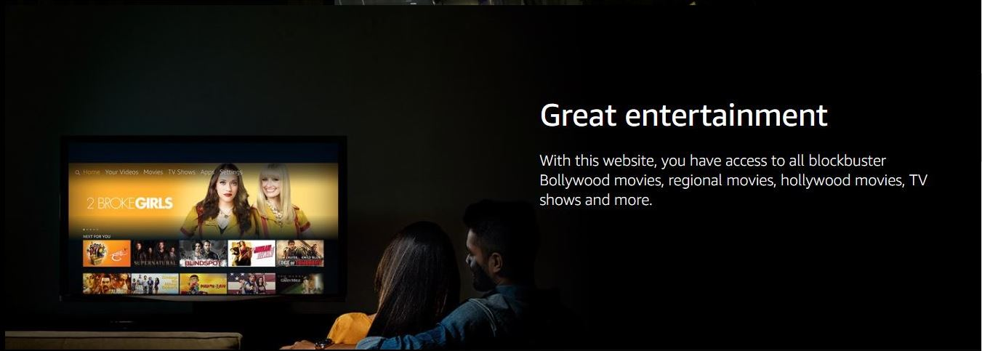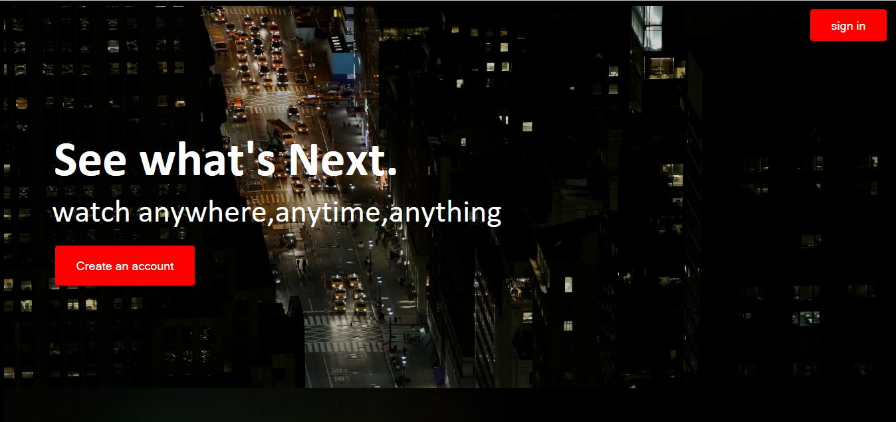

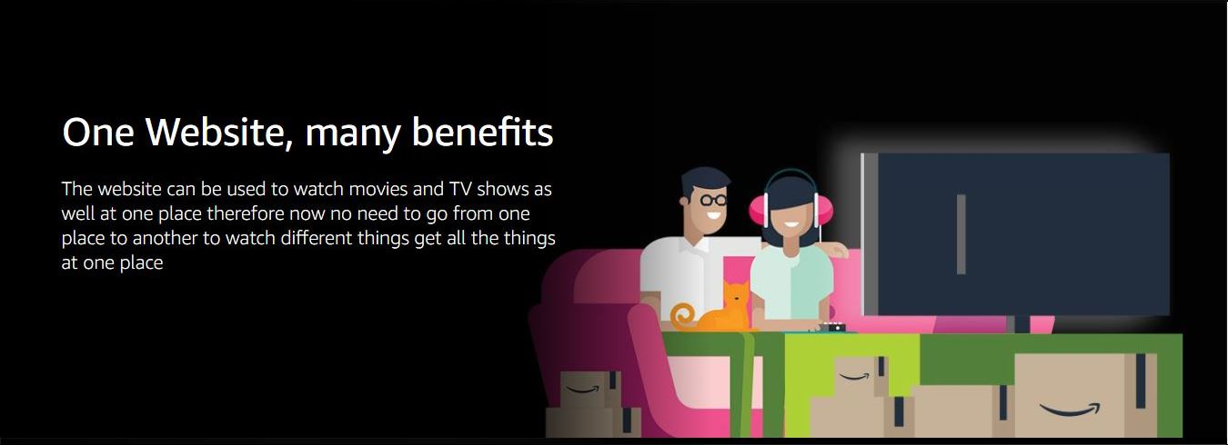

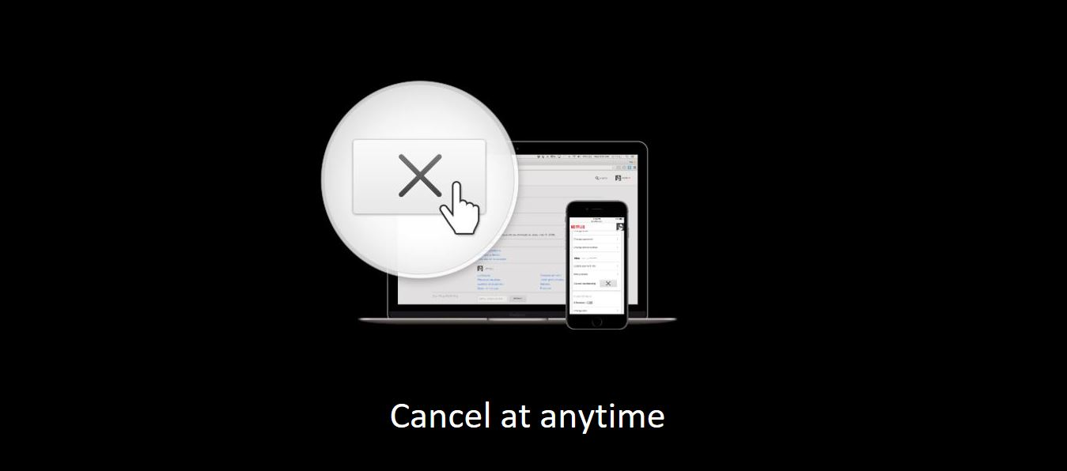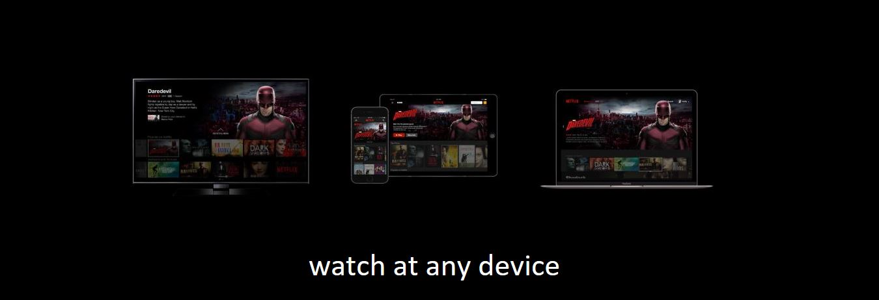



**ANIMATIONS USED:**

* **Create an Account Button:**



* **Sign in Button:**

AFTER CLICKING ON **CREATE AN ACCOUNT BUTTON**, ANOTHER

**SIGN UP** PAGE IS OPENED IN THE BROWSER:

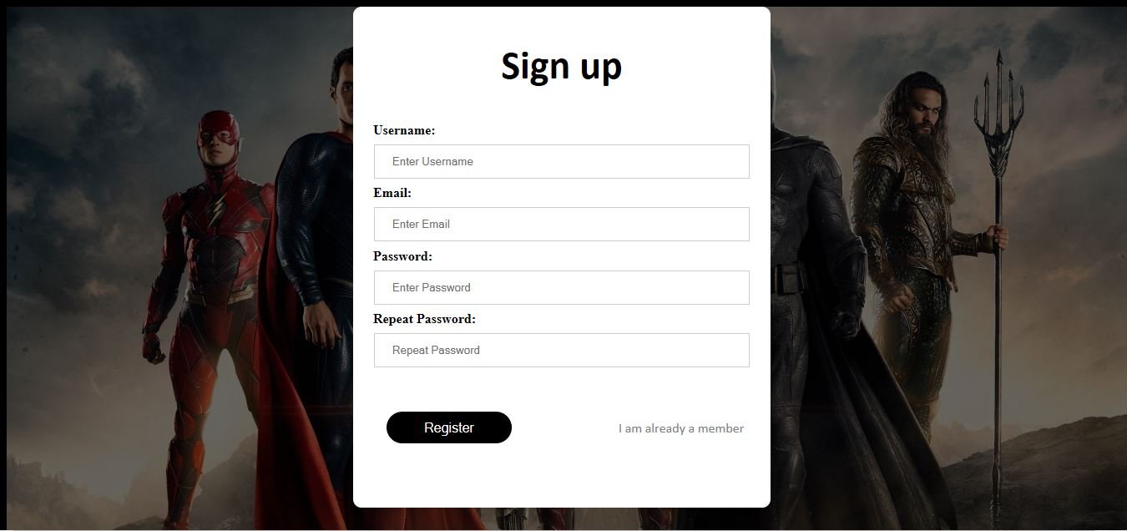

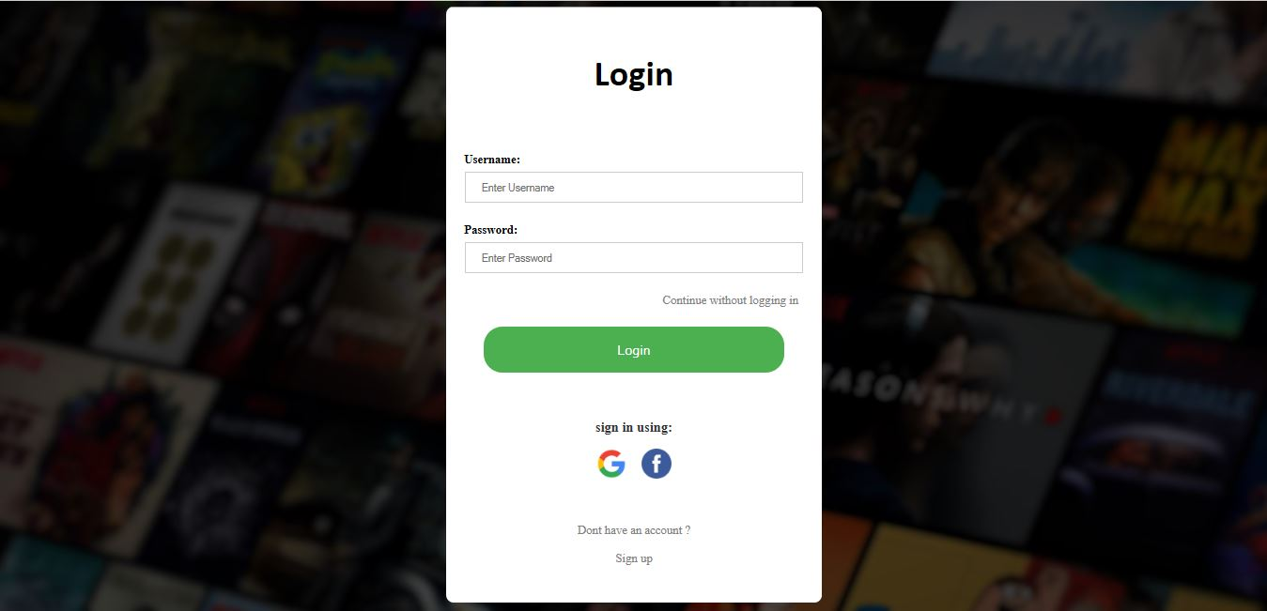WHEN YOU HAVE SUCCESSFULLY CREATED THE ACCOUNT IN THE SIGN UP PAGE, YOU CAN NOW MOVE TO LOGIN PAGE FROM THE **HOME PAGE** OR THROUGH **THE LINK** PROVIDED IN THE SIGN UP PAGE AS WELL, STATING “**I AM ALREADY A MEMBER**”. BY CLICKING ON THE BUTTON OR THE LINK PROVIDED YOU WILL BE DIRECTED TOWARDS THE **LOGIN PAGE**:

**Streaming Page**

AFTER YOU HAVE CLICKED ON THE **LOGIN BUTTON** OR **CONTINUE WITHOUT LOGGING** IN LINK, YOU WILL BE REDIRECTED TO THE **MAIN MOVIE STREAMING PAGE**.



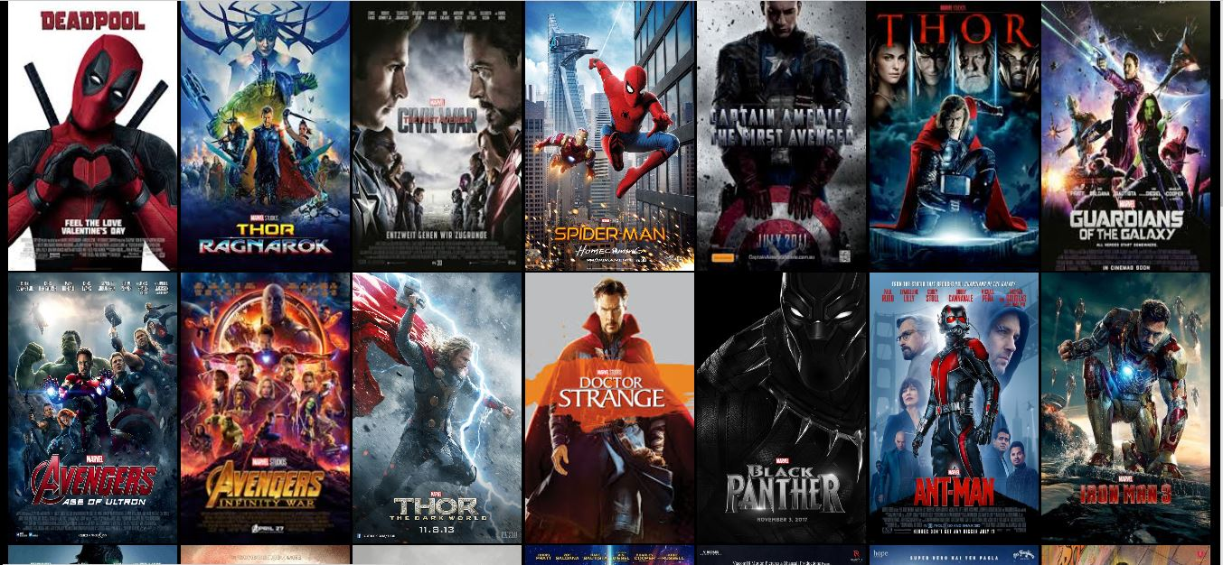

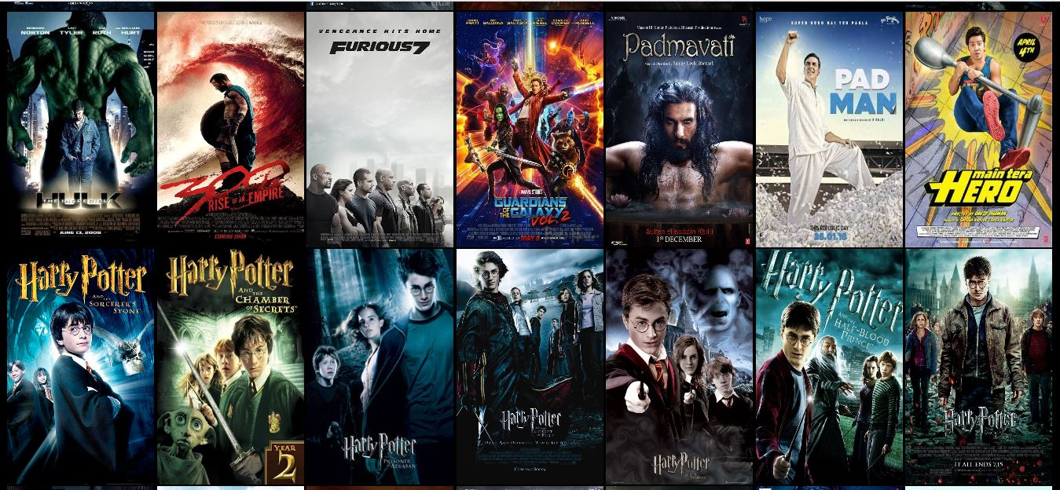

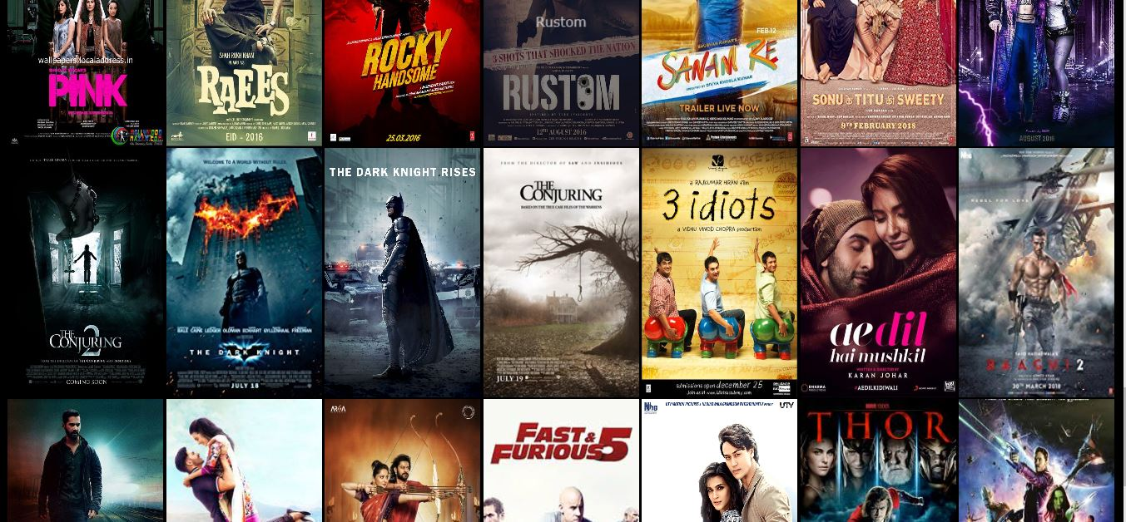

**THIS STREAMING PAGE INLUDES:**

* **TOP NAVIGATION BAR:**

C:\Users\Raghav\Desktop\pictures\9(a)side scroller.JPG

The navigation bar is a section of graphical user interface intended to aid visitors in accessing information. which contains:

1. **Side Scrolling Button:** The side scrolling button scrolls to the right side of page making the site look modern and which add further features of choosing the genre of the movies which is categorized into Action, Romance, Thrill, Hollywood, Bollywood, Comedy helping you to move into your right choice.

C:\Users\Raghav\Desktop\pictures\9(a)side scroller.JPG

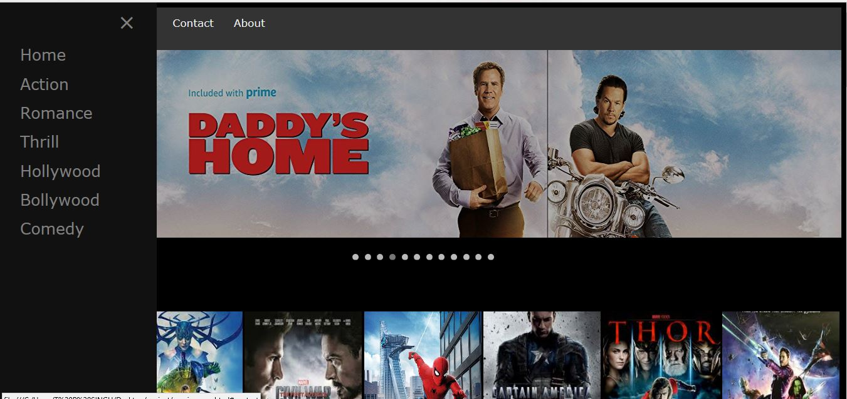

**THIS BUTTON FURTHER INCLUDES :**

**C:\Users\Raghav\Desktop\pictures\action.PNG**

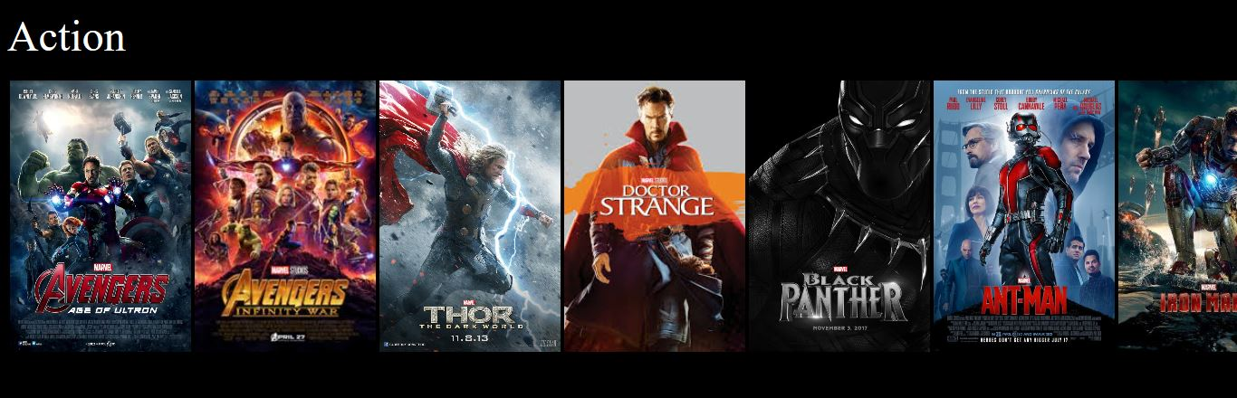

THIS IS A SCROLLING WINDOW, THE MOVIES CAN BE SCROLLED AND FROM RIGHT TO LEFT AND VICE VERSA TO IMPROVE THE WEBPAGE APPEARANCE AND ACCESSIBILTY.

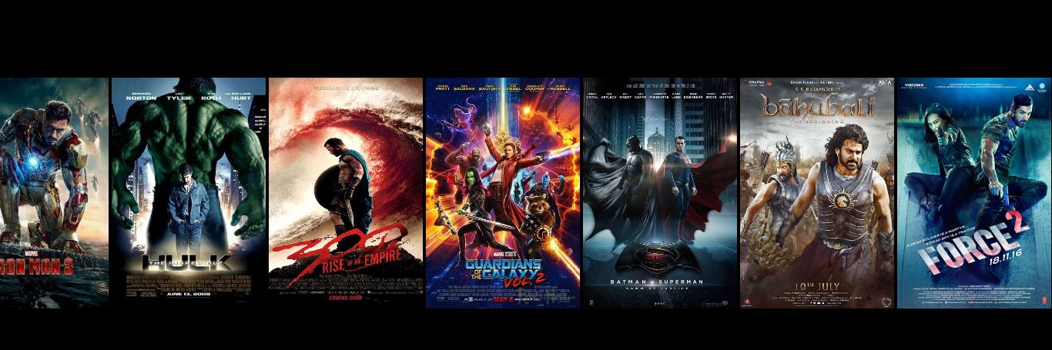

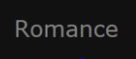

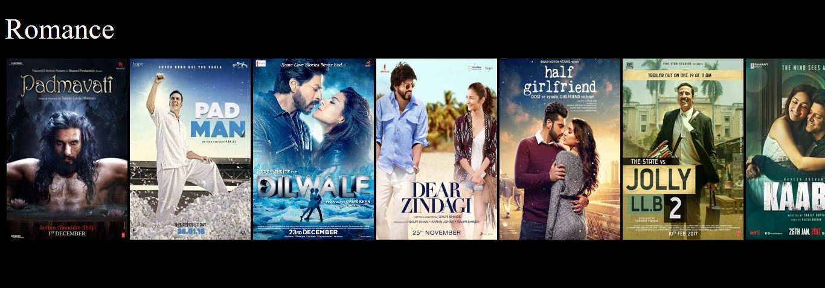

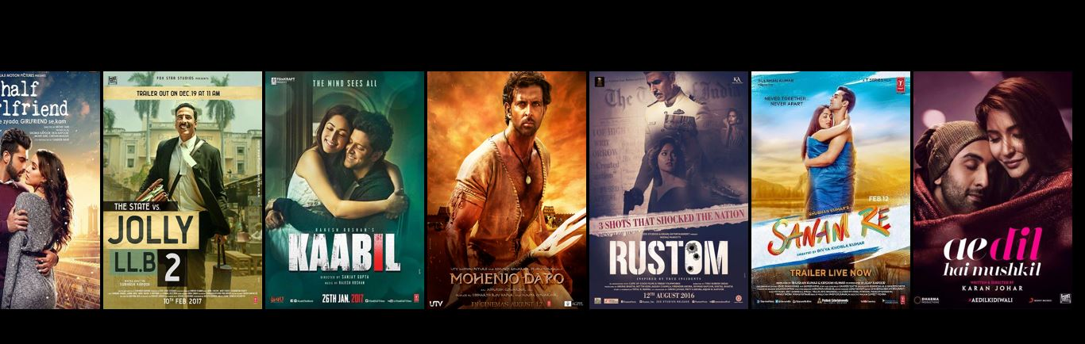

C:\Users\Raghav\Desktop\pictures\thrill.PNG

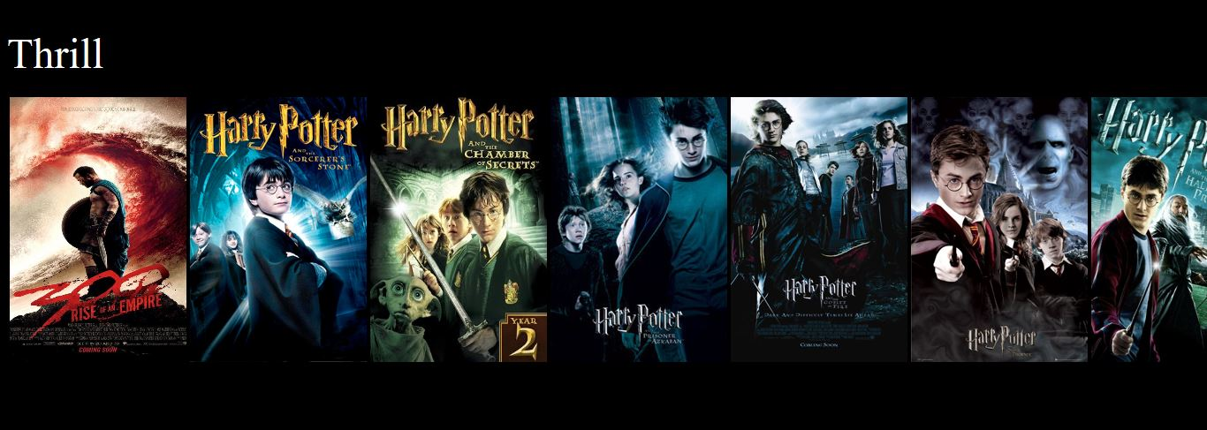

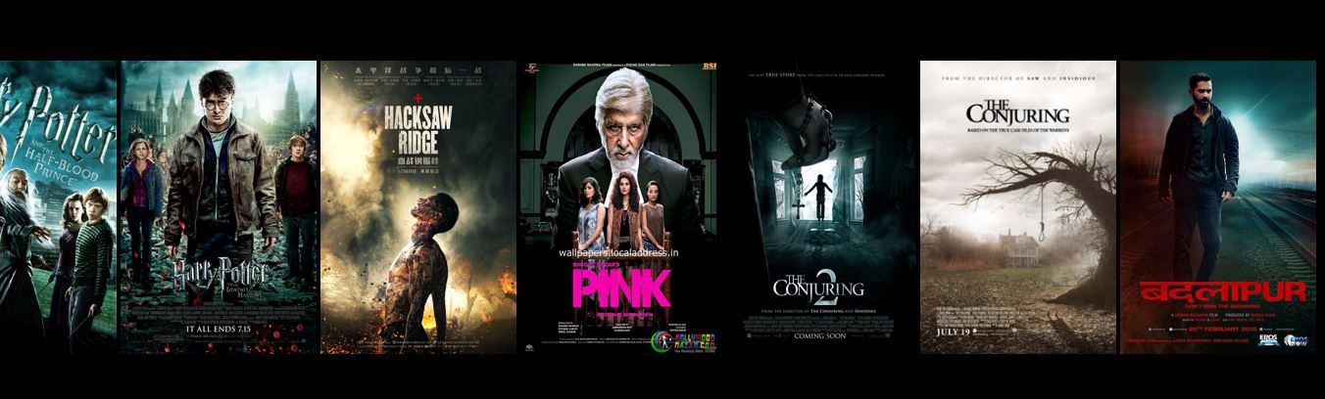

1. **Home:** Which takes you back to the home page of website. i.e. the movie streaming page.

C:\Users\Raghav\Desktop\pictures\home.PNG







1. **About us section:** Contains the information of website and it’s creators.
2. **Support:** Contains the contact details for customer support.

* **SLIDE SHOW CONTAINER:**

The slide show container shows the latest or upcoming movie posters as a slideshow in upper centre part of the streaming page.



* **LIST OF MOVIES:**

The list contains all the section of movies together. The list is given by the poster as well as the name of movie or tv show. So as you hover over the poster of the movie, you could actually see the **name** of movie **popping out** of the poster which makes the site looker much better.

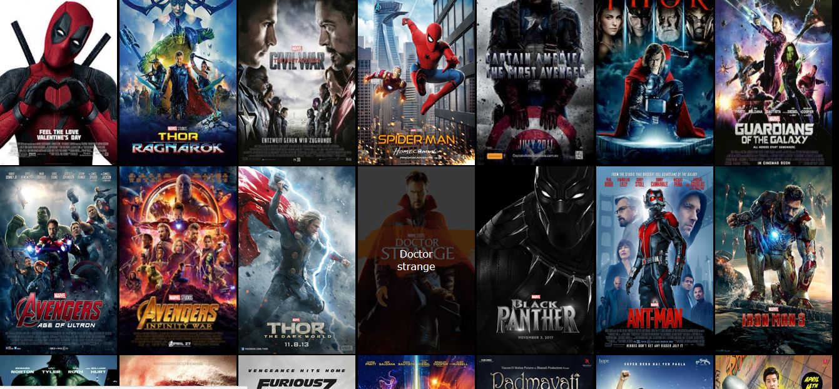

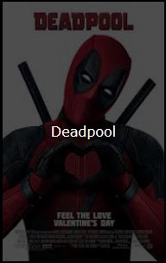



These images of movie posters are linked to the movie. So as you click on the poster of a particular movie, it starts streaming.

These movies can also be streamed through the Side scrolling bar which would open the genres of movies i.e. each movie is categorized into Action, Romance, Thrill, Hollywood, Bollywood, etc.



1. C:\Users\Raghav\Desktop\pictures\about.PNG**About us section:** Contains the information of website and its creators.

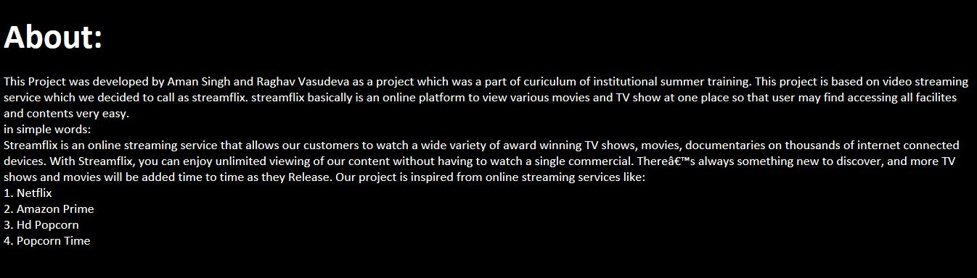

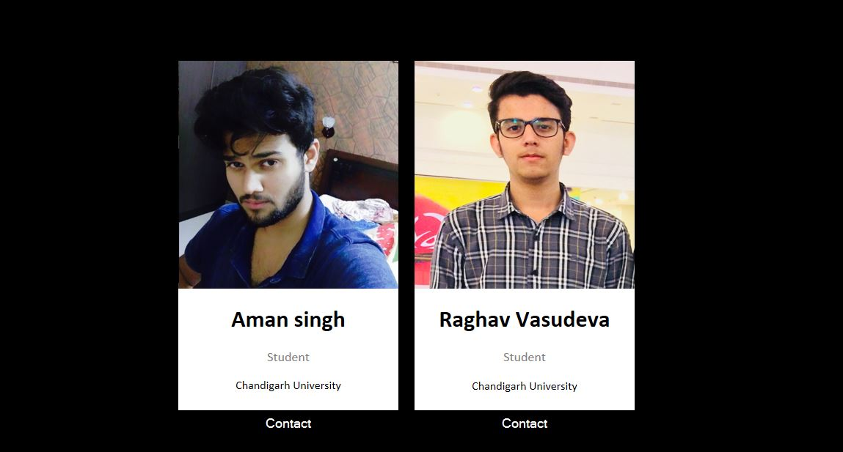

**RESULT AND DISCUSSIONS**

Implementation is the stage in the project where the theoretical design is turned into a working system and is giving confidence on the new system for the users that it will work efficiently and effectively.

It involves careful planning, investigation of the current system and its constraints on implementation, design of methods to achieve the changeover, an evaluation of change over methods.

Apart from planning major task of preparing the implementation are education and training of users. The implementation process begins with preparing a plan for the implementation of the system.

According to this plan, the activities are to be carried out, discussions made regarding the equipment and resources and the additional equipment has to be acquired to implement the new system.

In network backup system no additional resources are needed. Implementation is the final and the most important phase.

The most critical stage in achieving a successful new system is giving the users confidence that the new system will work and be effective.

The system can be implemented only after thorough testing is done and if it is found to be working according to the specification.

This method also offers the greatest security since the old system can take over if the errors are found or inability to handle certain type of transactions while using the new system.

**CONCLUSION AND FUTURE SCOPE**

**CONCLUSION:**

* Streamflix is, quite simply, a phenomenal service.
* It has tried to revolutionise the way we watch content, and has conquered the smartphone, tablet, computer and TV.
* Over the weekend or at the end of a long day, all you really want to do is fire something up on Streamflix, sit back and relax.
* However, it’s worth investigating what's tucked away inside its menus too – there are lots of handy features hidden just under the surface.
* You can, for instance, explore its many, many secret sub-genres, get access to its newest features before everyone else and even make TV shows and films look better on your screen.

**FUTURE SCOPE OR ENHANCEMENTS:**

* Add IMDB Rating to the movie streaming on Streamflix.
* Set Streamflix to automatically Pause when you fall asleep.
* Skip the Spoilers on Streamflix.
* Customize Your Subtitles.
* Watch Out Of Hours For A Smoother Stream.
* Live Stream Your Reaction or Movie Experience.

**REFERENCES**

[http://www.w3schools.com/html/html\_intro.as](http://www.w3schools.com/html/html_intro.asp)p

[http://www.w3schools.com/css/css\_background.as](http://www.w3schools.com/css/css_background.asp)p

[http://www.w3schools.com/js/js\_datatypes.as](http://www.w3schools.com/js/js_datatypes.asp)p

[http://www.w3schools.com/sql/sql\_insert.as](http://www.w3schools.com/sql/sql_insert.asp)p

[http://www.w3schools.com/sql/sql\_update.as](http://www.w3schools.com/sql/sql_update.asp)p

[http://www.w3schools.com/php/php\_forms.as](http://www.w3schools.com/php/php_forms.asp)p

Fundamentals of software engineering by Rajib mall, PHIlearning

Web development and application development by Ivan Byross BPB publications

